2024 ALGWA Vic Bursary Award

We're incredibly grateful to Ventia and LGPro for their support in continuing our work within the local government sector.

ALGWA Vic is excited to announce our 2024 Bursary Award Event, where council members can nominate a staff member, who is studying to further their career, for the chance to win:

- a $2,500 cash prize,
- the opportunity to participate in the judging panel for the 2025 Bursary Award applications.

We are also thrilled to have LGPro join us in celebrating this event by providing the winner with:

- Access to one LGPro course over the next 12 months of the winner's choice, up to $2,500 (excluding ASQA-certified courses),
- A ticket to the LGPro Women's Conference,
- An invitation to the LGPro Women's Conference end-of-conference dinner

Additionally, every nominee for the 2024 Bursary Award will receive a 50% discount to ALGWA Vic’s upcoming workshop on 19 July 2024, facilitated by Australia’s Keynote Speaker of the Year, Dr Louise Mahler.

The 2024 event will take place on Thursday 8 August, supported by our event sponsor Ventia.

Take advantage of this chance to nominate yourself for the ALGWA Vic Bursary Award and be recognised for your outstanding dedication to bettering our communities. We look forward to receiving your nomination!
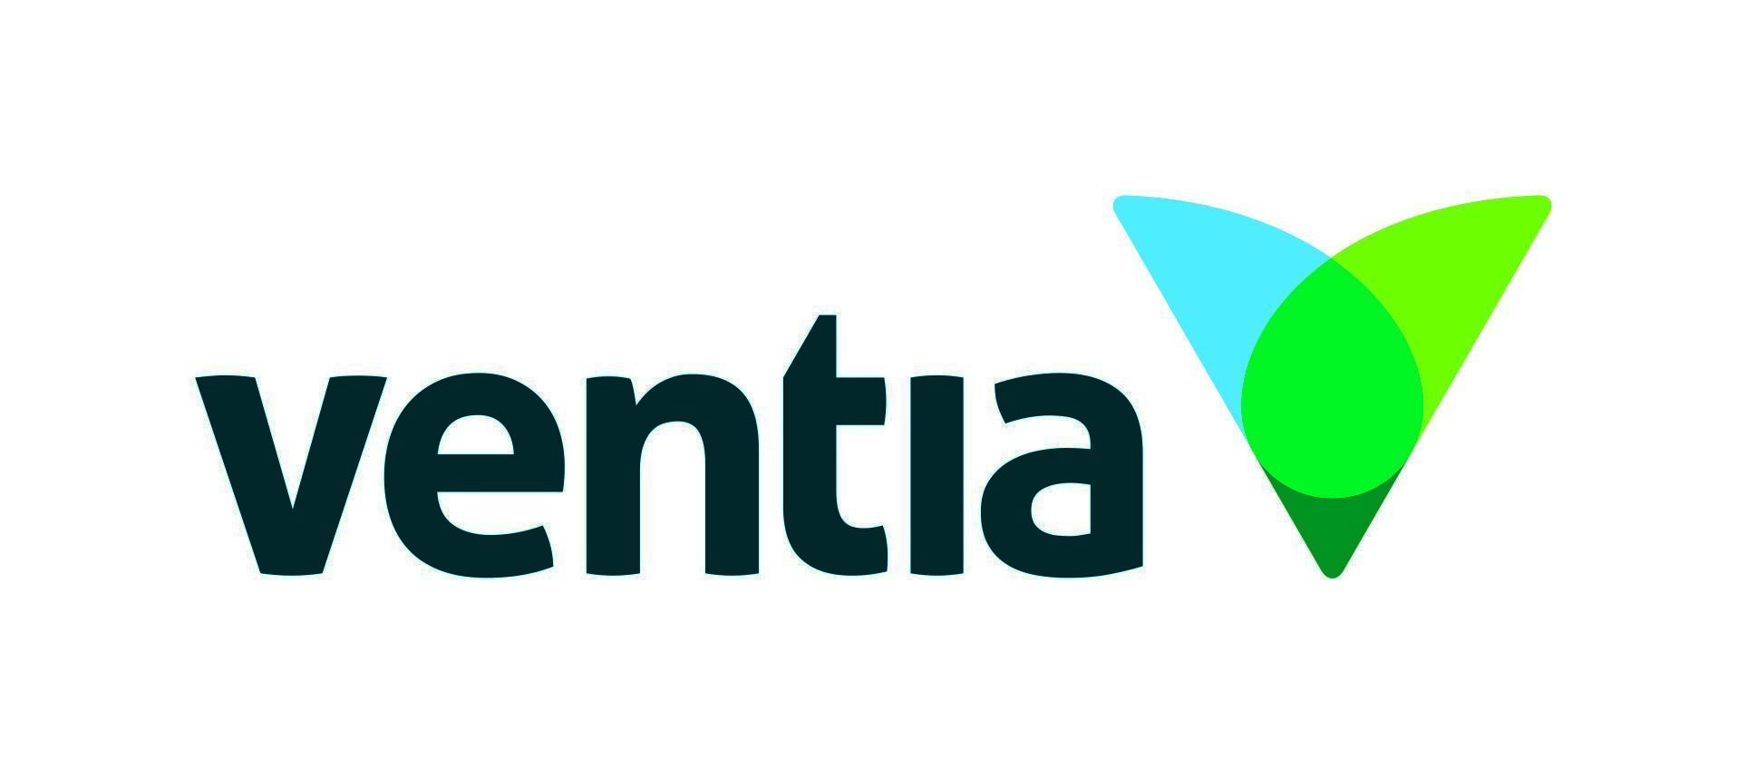

Nomination form

Please complete this form and return it in PDF file format to the Executive Officer of ALGWA Vic at admin@algwa.com.au with the subject line ‘2024 Bursary Award Nomination – Your Name’.

Please only include the requested information, as any additional documentation will not be provided to the judges.

Date of submission | Click to enter date.
Signature

ALGWA VIC 2024 BURSARY AWARD DATES

- Saturday, 27 April 2024
Bursary Award nominations open at the ALGWA Vic 2024 Annual Conference

- Monday, 24 June 2024
Bursary Award nominations close at 11:59pm AEST

- Friday, 28th June 2024
Interviews will be held

- Monday, 1 July 2024
Bursary Award judges return their assessments for endorsement by ALGWA Vic Executive Committee

- Tuesday, 9 July 2024
Finalists will be notified

- Thursday, 8 August 2024
Bursary Award Event at Glasshaus Brucke, Richmond, where winner is announced

ALGWA VIC BURSARY AWARD

ALGWA Vic is committed to encouraging women to advance their careers in the local government sector through study.

That's why, in 1989 (under the leadership of then-President Pam Robinson AM), ALGWA Vic established an Annual Bursary Award to encourage and assist women working in the local government sector to further their education.

Since then, the prize has been awarded to over 30 women from member councils across metro and regional Victoria.

LETTER OF RECOMMENDATION REQUIREMENTS

As evidence of their work ethic and achievements, all ALGWA Vic 2024 Bursary Award applicants are required to provide letters of recommendation alongside their application.

Using your Council’s letterhead, please type a letter of support outlining the applicant’s achievements addressing the following criteria:

- Work performance and integrity
- Major achievements within the workplace
- Commitment to professional development
- Commitment to local government

Please address your letter to the ALGWA Vic Executive Officer. When signing the letter, include your position within your Shire or Council.

Thank you for assisting the applicant in achieving their goals.

REFEREE DETAILS

- I have included two Letters of Recommendation with this nomination.
- I have provided my referees with the Letter of Recommendation requirements.
See Page 2.
Reference 1 | Full Name | Type here.
 | Phone | Type here.
 | Email | Type here.
 | Position | Type here.
 | Organisation | Type here.
 | Relationship | Type here.
Reference 2 | Full Name | Type here.
 | Phone | Type here.
 | Email | Type here.
 | Position | Type here.
 | Organisation | Type here.
 | Relationship | Type here.

NOMINEE DETAILS

Given Name | Type here. | Family Name | Type here.
Phone (W) | Type here. | Phone (M) | Type here.
Email | Type here.
- .jpeg photo attached to be used for Bursary Award purpose
- I can confirm your council is an ALGWA Vic member

MORE ABOUT YOU

Council Employer | Type here.
Current Position | Type here.
Length of time employed in local government | Type here.
Bio  (No more than 75 words. Used for finalists and winner) | Type here.

EDUCATION

Current Course Name | Type here.
Name of Institution | Type here.
Completion date of study | Type here.
Number of completed units | Type here. | of | Type here. | units.

SUPPORTING INFORMATION

What relevant experience do you have to support your application further?
Include information about your involvement within the community, volunteering, internships, experiences abroad, etc.
Type here.

Why are you applying for this award?
Minimum 200 words.
Type here.

What has led you to undertake further study?
Minimum 100 words.
Type here.

What are your career aspirations for the next 5 years?
Minimum 200 words.
Type here.

What does it mean to you to have ALGWA Vic supporting women working within local government?
Minimum 250 words.
Type here.

What role of leadership will you undertake as the Bursary Award winner to further the awareness of this award within the sector?
Minimum 200 words.
Type here.

How do ALGWA Vic’s values align with your personal and work ethic? Explain how you demonstrate your leadership qualities, apply your studies within the community, and are a role model of ALGWA Vic’s values.
Minimum 250 words.
Type here.

Please submit this form in PDF format to the ALGWA Vic Executive Officer at admin@algwa.com.au by Friday, 14 June 2024, 11:59 pm AEST.

You can attach character references and any other supporting documentation to this email.

Our Executive Officer will receipt your submission, and send through a 50% discount code for your ticket to ALGWA Vic’s upcoming workshop on 19 July 2024:
3-Hour Workshop with Dr Louise Mahler - Australian Keynote Speaker of the Year
trybooking.com/CRXCV

